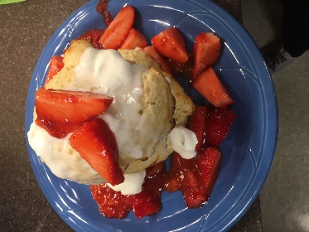
Strawberry Shortcake
Shortcake  Yield: 4 Cakes  Ingredients:  - 1 c. flour  - 2 t. baking powder  - 1/4 t. salt  - 3 T. sugar  - 1/4 c. butter  - ½ c. milk  Directions:  - Preheat oven to 450.  - Combine dry ingredients in batter bowl.  - Cut butter into dry ingredients using cheese grater, and gently mix to coat butter with dry ingredients.  - Add milk and stir until combined.  - Drop 4 large spoonfuls of dough on baking sheet lined with parchment paper.  - Bake 8 minutes. (Bottoms will be golden but tops will look white). |  | Strawberry Sauce  Yield: 2 cups  Ingredients:  - 1 c. frozen strawberries  - 2 T. sugar  - 1 c. fresh strawberries  Directions:  - Place frozen strawberries and sugar in microwave safe bowl or on plate, and microwave for 30 seconds.  - Using a potato masher, mash strawberries and sugar until saucy.  - Slice fresh strawberries and combine with strawberry sauce – save a few for garnish.  - Place on top of warm biscuits. |  | Whipped Cream  Yield: 1 ½ Cups  Ingredients:  - 2/3 c. heavy cream  - 1/2 t. vanilla  - 2 T. powdered sugar  Directions:  - Pour cream, vanilla and powdered sugar into clean, dry mixing bowl.  - On high speed, whip cream until it begins to thicken. Approximately 2 minutes.  (Do not over-mix the cream!)  - Place on top of biscuits and strawberry sauce.

